Feminist Art Theory Power: Term Paper
Intersectional Feminist Art
Mitali Shukla
Fall 2019

INTRODUCTION
Art often reflects the context in which the artist was situated in; within the context of feminist art, the canon has often been dominated by cisgender, white females who garner the most recognition in the field. Historically, minor art, or the cultural production of outsiders, has differed from that of the dominant culture. Minor art made by African Americans carry a different set of themes that transcend that of the dominant culture; in this case, the artists that have typically created the canon – what is traditional art – do not carry the same weight or have the same audience that minor art does. In Abigail Solomon-Godeau’s “Taunting and Haunting,” she describes the binary set of artistic tactics which allow the audience to interpret an art piece critically and affectively. Solomon-Godeau begins by defining taunting as “a response to particular and public forms of social and cultural expression” (Solomon-Godeau 2006:373). It is addressed to the often white, male spectator as well as being more aggressive and confrontational than haunting. Haunting, on the other hand, she defines as “the conjuring of historical absences and silences,” bringing to light what is hidden and unsaid. It turns “on the mechanisms of historical and cultural repression” and involves “a past that refuses to be done with” (Solomon-Godeau 2006:378). Avery Gordon identifies the thread that connects haunting and African-American art in her study “Ghostly Matters”: “Whatever can be said about the long and varied traditions of African-American thought, writing, and radicalism, the social reality of haunting and the presence of ghosts are prominent features” (Solomon-Godeau 2006:378). To challenge the norm of what constitutes great art, highlighting intersectional feminist art helps us difference the canon. Giving a voice to those who have experienced erasure is imperative to creating art that resonates with minorities. Artists Betye Saar, Faith Ringgold, and Carrie Mae Weems utilize taunting and haunting in their work to convey themes regarding the intersection of race and gender and the implications of such an identity.

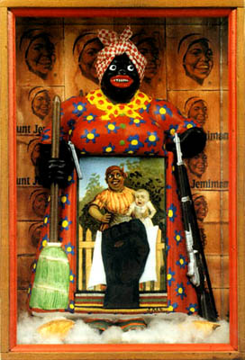
BETYE SAAR
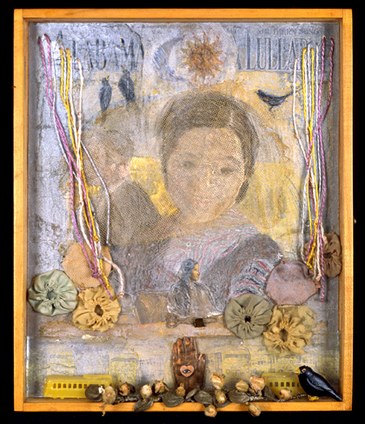
One of many racist characters conjured by the dominant culture in America’s deep-seeded history of racism is Aunt Jemima. Deemed a derogatory figure, she is characterized as an asexual, motherly nanny who takes care of white children despite having none of her own. One might recognize her on a bottle of syrup at the grocery store. The image of Aunt Jemima was so pervasive at one point that the first Academy Award given to a Black woman was for an archetype of the “mammy” figure in the film “Gone with the Wind” to actress Hattie McDaniel (Rydall 2019). Betye Saar’s most noteworthy piece, “The Liberation of Aunt Jemima,” shows the caricature of the “mammy” trope in a different light. Bell Hooks describes the oppositional gaze as a type of looking that acknowledges power dynamics and acts as a form of rebellion towards those with greater power. Saar’s use of the oppositional gaze in the piece challenges the notion that Aunt Jemima is powerless in comparison to white folk. This constitutes the utilization of not only the oppositional gaze but reversal. One aspect of taunting is “the use of the stereotype,” whereas another is “what situationists called ‘detournement,’ or reversal” (374). Saar takes the reputation of Aunt Jemima as a caring, motherly caricature and instead chooses to present her as an armed warrior. The piece serves as a symbol of black liberation as well as radical feminist art. Saar’s piece “Victory of Gentleness (for Rosa Parks)” serves as a mixed-media response to racial apartheid as well as the intersection of racism and sexism (Brodsky & Olin 2008:333). It follows the societal transition from slavery to current “modes of racial discrimination” (Brodsky & Olin 2008:334). As a precursor to the art style postmodernism, Saar utilized the blurring of boundaries with an open composition, texture, merging the altar, window, and vanity (Brodsky & Olin 2008:334). The work of Betye Saar serves as only a small part of black feminist art which differences the canon of what constitutes great art as well as using haunting to bring attention to historical events which bleed into this day and age.
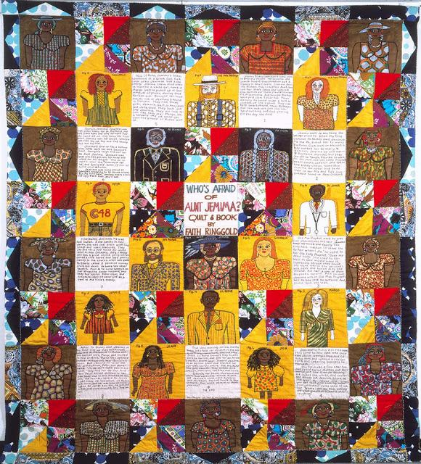
FAITH RINGGOLD
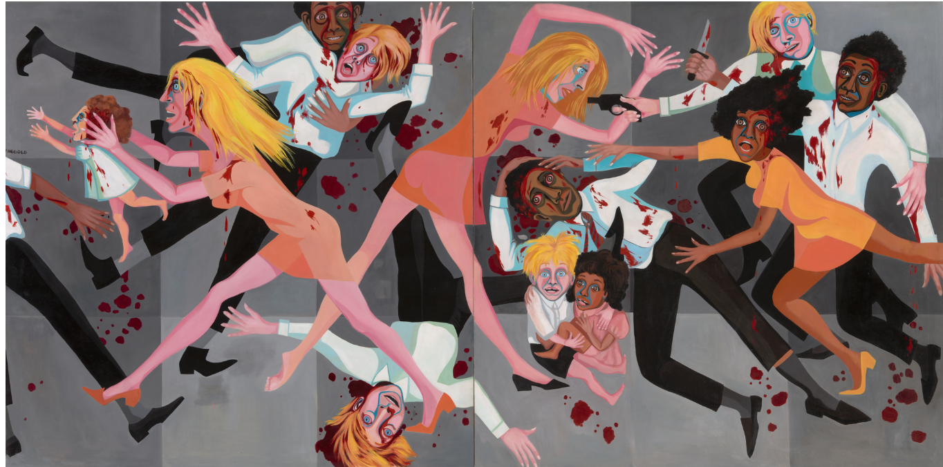
Black feminist art regarding the trope of Aunt Jemima is not limited to the work of Betye Saar. In Faith Ringgold’s piece honoring Aunt Jemima, she creates a quilt with her mother called “Who’s Afraid of Aunt Jemima?” The quilt consisted of textiles that depicted the story of a successful black woman. She presents the character as an entrepreneur so as to reclaim Jemima; Ringgold frames her as an empowering figure rather than the derogatory figure that we are accustomed to. The piece also provided commentary regarding the depiction of black females in art, which is tainted by stereotypes of black women such as Jemima herself. Another piece of Ringgold’s that provides commentary on the black experience is titled “American People Series: Die #20.” It depicts racial tensions during the 1960s that manifested in the form of riots (Rydall 2019). Upon viewing this work for the first time, I found it incredibly familiar. What I failed to realize until later was that it was inspired by Pablo Picasso’s “Guernica.” Ringgold presented the violence that occurred in response to the Civil Rights movement. The bright colors in stark contrast with the grey background provide for a jarring display of violence and unruliness. Ringgold’s artwork challenges the notion that black people fit into pre-conceived stereotypes that present them as one dimensional in addition to utilizing the taunting technique to callout out spectators that reside within the parameters of the dominant culture.

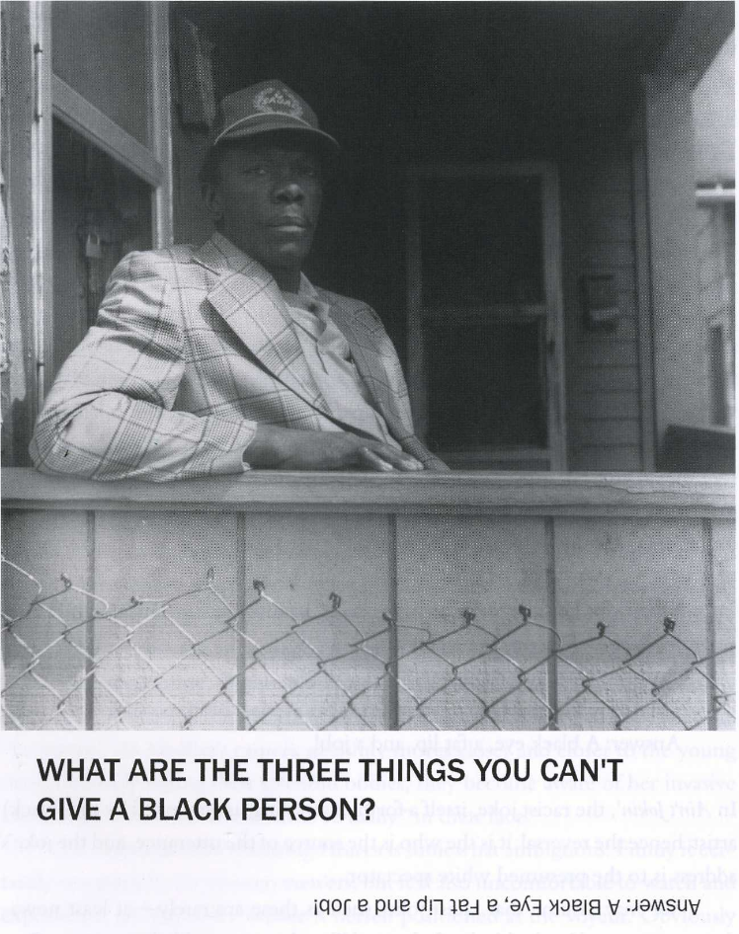
CARRIE MAE WEEMS
Solomon-Godeau identifies the work of Carrie Mae Weems as one of the most prominent examples of an artist who utilizes taunting in their work. In her collection of pieces, “Ain’t Jokin’,” Weems uses racist jokes alongside pictures of black folk to satirize the dark humor that was pervasive in this country just a few decades ago. The work titled “What Are the Three Things You Can’t Give a Black Person?” from “Ain’t Jokin’” jokes that you cannot give a Black person a black eye, a fat lip, and a job. The joke highlights stereotypes of black folk based on their complexion, facial features, and their labor abilities. America’s history is tainted with Minstrel Shows that extrapolated on such stereotypes to the point where caricatures of black folk were conjured based on these assumptions. One of such fabrications became Aunt Jemima. “The racist joke, itself a form of taunting, is generated by the (black) artist; hence the reversal: it is she who is the source of the utterance, and the joke’s address is to the presumed white spectator” (Solomon-Godeau 2006:375). These offensive jokes are presented by Weems so as to make the white audience uncomfortable – one of the most common intentions of haunting. “A spectator might find them secretly funny, or alternatively, vulgar and offensive, the response itself might be marked by discomfort, guilt, embarrassment” (Solomon-Godeau 2006:375). Weems also blurs the line between fantasy and reality through the title of the collection – “Ain’t Jokin’” – white folks weren’t joking when they made these jokes because these stereotypes are still relevant today. Unemployment for African Americans is just one of the ways that current modes of racial discrimination manifest today. The implications of these stereotypes actually manifest in the ideology that black folk are not conventionally attractive or that they are lazy and consequently, jobless as a result. These assumptions hold true because they are utilized by the dominant culture to oppress that of the minority.

CONCLUSION
Black females in America occupy a distinct space in society: their identity resides at the intersection of being black in a historically oppressive country, but also being a female in a society that is so inherently misogynistic. The implications of Solomon-Godeau’s “Taunting and Haunting” are that minor art is a medium from which minority groups, black women in particular, can communicate themes that are unique to their experience due to historical events that shape the reality of today’s socio-political climate. As Gordon highlights in “Ghostly Matters,” “being haunted draws us affectively, sometimes against our will, and always a bit magically, into the structure of feeling of a reality we come to experience, not as cold knowledge, but as a transformative recognition” (Solomon-Godeau 2006:397). The utilization of taunting and haunting tactics serves as a form of consciousness-raising for those unfamiliar with the black female experience. Black women play an instrumental role in American society today: in 2018, black women made up 53 percent of the black labor force in 2018 (Bureau of Labor Statistics). In 2060, women of color will be the majority of all women in the United States (Catalyst). However, women of color and black women are not interchangeable. Feminism that doesn’t include all women isn’t really feminism; thus, the importance of intersectional feminism coincides with feminism in its very definition: the theory of the political, economic, and social equality of the sexes.

REFERENCES

Anon. 2019. “Black Women Made up 53 Percent of the Black Labor Force in 2018.” U.S. Bureau of Labor Statistics. Retrieved December 14, 2019 (https://www.bls.gov/opub/ted/2019/black-women-made-up-53-percent-of-the-black- labor-force-in-2018.htm).

Anon. n.d. “Women of Color in the United States: Quick Take.” Catalyst. Retrieved December 14, 2019 (https://www.catalyst.org/research/women-of-color-in-the-united-states/).

Brodsky, Judith K. and Ferris Olin. 2008. “Stepping Out of the Beaten Path: Reassessing the Feminist Art Movement.” Pp. 329–40 in Signs.

Solomon-Godeau, Abigail. n.d. “Taunting and Haunting: Critical Tactics in ‘Minor’ Mode.” Pp. 371–97 in.

Rydall, Willa. 2019. “Faith Ringgold: Art as an Image of Who You Are.” Vagina Wolf. Retrieved December 13, 2019 (https://vaginawoolffap.wordpress.com/feminist-artist/).

ARTWORK
Ringgold, Faith. "The American People Series #20: Die” (1967) Oil on canvas. 72 x 144 in. Museum of Modern Art, New York.
Ringgold, Faith. “Who’s Afraid of Aunt Jemima?” (1983) Acrylic on canvas, dyed, painted and pieced fabric. 90 x 80 in. Private collection.
Saar, Betye. “The Liberation of Aunt Jemima” (1972) Berkeley Art Museum and Pacific Film Archive.
Saar, Betye. “Victory of Gentleness (for Rosa Parks)” (1975) Mixed-media assemblage. 13.5 x 11.25 x 1.25 in. Collection of Donna Mussenden VanDerZee.
Weems, Carrie Mae. “What Are the Three Things You Can’t Give a Black Person?” from “Ain’t Jokin’”. (1987-88). Silver print. 20 x 16 in. Pilkington Olsoff Fine Arts, New York.

